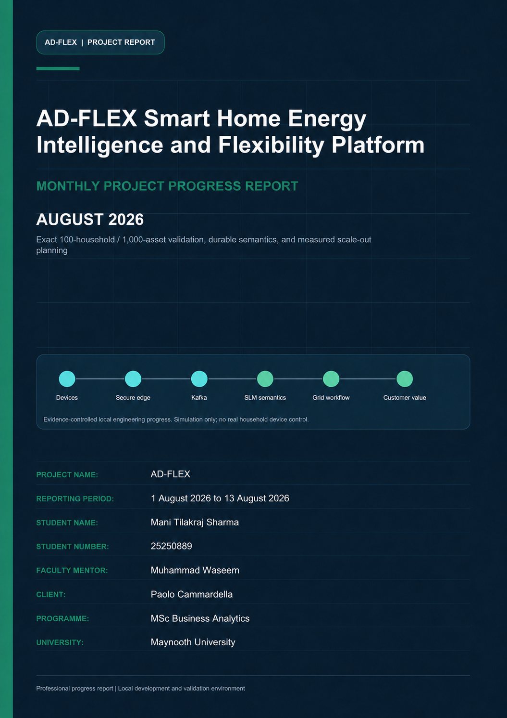

Document Control
Project Name | AD-FLEX
Document | AD-FLEX Monthly Project Progress Report - August 2026
Reporting period | 1 August 2026 to 13 August 2026
Student Name | Mani Tilakraj Sharma
Student Number | 25250889
Faculty Mentor | Muhammad Waseem
Client | Paolo Cammardella
Programme | MSc Business Analytics
University | Maynooth University
Version | 1.0
Document date | 13 August 2026
Distribution | Paolo Cammardella, Muhammad Waseem, academic review, and technical management

Evidence and claim standard
Git history is the primary implementation timeline. Live results are included only where the repository contains a dated report or machine-readable artifact. Implemented, validated, demonstrated, planned, and future-production items remain distinct throughout this document.

Protocol and dataspace references describe simplified IEEE 2030.5-style and ENERSHARE/IDS-ready foundations. They do not assert certification. All device-command evidence is simulated and retains no_real_execution=true.
This report should be read with the month-specific evidence audit and the July-August cross-month consistency check retained in docs/monthly-reports.

Table of Contents
The contents follow the report heading hierarchy. Page numbers appear in the document footer.
1. Executive Summary
2. Project Objective
3. Position at the Start of the Month
4. Monthly Development Focus
5. Major Work Completed
6. End-of-Month Architecture
7. Component Progress
8. SLM and Semantic Intelligence
9. Household and Device Simulation
10. Scalability Development
11. Validation and Testing
12. Customer/Product Development
13. Business Value for EnerShare
14. Technical Challenges and Resolutions
15. Safety, Security and Governance
16. End-of-Month Project Status
17. Next Development Priorities
18. Monthly Achievement Summary
19. Conclusion
Appendix A - Git Evidence
Appendix B - Validation Evidence
Appendix C - Current Limitations

1. Executive Summary
August focused on converting July's scalable architecture and household fleet into an exact, reproducible 100-household / 1,000-asset validation programme. The work did not replace the existing AD-FLEX business workflow. It made population construction deterministic, preserved reading identity end to end, expanded semantic guardrails for every selected category, added reproducible stage tooling, and made customer queries suitable for a 1,000-asset cohort.
The population contains 30 apartment households with eight assets each, 50 standard homes with ten assets each, and 20 prosumer homes with thirteen assets each. The resulting 1,000 devices cover smart meters, smart plugs, refrigerators, washing machines, lighting, water heaters, thermostats/HVAC, dishwashers, heat pumps, EV chargers, solar inverters, and home batteries. One bounded fleet/generator process schedules deterministic offsets and sends one primary semantic reading per asset for population tests. Complete multi-field telemetry remains available in a separate coverage mode.
Semantic processing remained mandatory. Every normalized reading was submitted to local Ollama Phi-3 Mini. Deterministic SAREF4ENER logic only validated, rejected, retried, or marked a result safely unmapped; it did not create replacement mappings. Preflight tests compared batch sizes 1, 8, 16, 32, and 64. Batch 8 provided the best local balance because all eight outputs passed strict validation at 0.547 readings per second, while larger batches produced increasing structured-output failure.
The 5 August full-field coverage run represented 100 assets across all 12 exact-profile categories and generated 374 normalized readings. All 374 recorded slm_called=true, 339 model proposals passed validation, 35 became explicit safely-unmapped terminal outcomes, no final rows were duplicated, no processing errors occurred, and Kafka lag returned from a maximum of 159 to zero. The representative DSO, approval, mock dispatch, device translation, and dataspace workflow also completed without unsafe execution.
A separate 5 August 15-minute 1,000-asset run accepted and completed all 1,000 updates with 100% SLM invocation, 961 validated mappings, 39 safely-unmapped outcomes, zero drops, zero duplicates, zero processing errors, and final Kafka lag zero. It did not pass the sustained-rate criterion. Arrival was 1.102 readings per second and durable completion was 0.445 readings per second. Backlog clearance took 1,345.714 seconds after generation, indicating a 2.478x inference-capacity gap before operating headroom. The result is classified functional_only, not sustained local real time.
The repository also formally incorporated machine-readable staged functional evidence produced on 27 July. That evidence records asynchronous end-to-end passes at 100, 250, 500, and 1,000 assets, including a 1,000-asset run with 969 validated mappings, 31 safely-unmapped outcomes, zero final lag, and complete representative flexibility/dataspace processing. Its execution date remains July; August receives credit for the integration, fixes, reporting, and fresh validation rather than retroactively moving the run.
At the current August position, AD-FLEX has a credible 1,000-asset local functional demonstration, complete mandatory-SLM evidence, durable idempotency controls, bounded customer aggregation, and a measured infrastructure model for larger deployments. The exact bottleneck is the single local Phi-3 Mini tier. Million-device material is a scale-out model only; no 10,000-, 100,000-, or million-asset end-to-end validation is claimed.
August management conclusion
The complete local workflow supports controlled asynchronous functional completion for exactly 100 households and 1,000 simulated assets. The same laptop does not sustain the tested arrival rate; additional validated inference capacity is required before a real-time scale claim.

2. Project Objective
AD-FLEX transforms heterogeneous household energy data into standardized, semantically governed information that can support household intelligence, flexibility participation, grid-facing messages, safe approval workflows, simulated device-language translation, and privacy-aware data products. Its business objective for EnerShare is to reduce vendor-specific integration friction while retaining traceable evidence and strict control boundaries.
August tested whether the same logical architecture could represent an exact 1,000-asset portfolio without one process per device and without bypassing the local SLM. The test objective was functional completion and measured capacity, not a claim of production high availability or million-device processing.

3. Position at the Start of the Month
As of the final July commit, the platform already had mandatory-SLM batching/provider foundations, a role-aware customer product, an internal operations dashboard, a 20-household/241-device fleet, and a protected public-demonstration path. Table 1 records the inherited position and the August refinement target.
Table 1. August starting position and required refinement
Area | State at 31 July | August requirement
Fleet | 20 households, 241 devices, range-random profiles | Exact 30/50/20 profiles and exactly 1,000 assets
Semantic flow | Mandatory batching/provider foundation | Category-complete primary readings, strict quality benchmark, 100% audit
Durability | Reading IDs and conflict-aware writes | End-to-end idempotency and retry identity across the scale run
Kafka | Single broker; scale topics and lag tooling | Six main-topic partitions and isolated consumer evidence
Customer product | Bounded household dashboard | Exact cohort aggregate, search/profile filters, pagination
Scale evidence | 15-device pass; 241-device delivery demo; failed first capacity gate | Staged functional and sustained classification

4. Monthly Development Focus
Create exactly 100 unique households and exactly 1,000 unique assets from deterministic profile inventories.
Use one bounded generator process and deterministic reporting offsets rather than per-device containers or timers.
Submit every generated normalized reading to local Phi-3 Mini and retain full terminal SLM evidence.
Preserve deterministic SAREF4ENER as validator/retry/safe-unmapped logic only.
Benchmark local micro-batches and select a stable configuration from measured quality and throughput.
Guarantee stable message/reading identities, conflict-safe durable writes, zero silent drops, and duplicate detection.
Execute staged and sustained validations through semantic, IEEE-style, flexibility, mock dispatch, device translation, dataspace export, and dashboard views.
Build a measured future infrastructure model without claiming unexecuted scale.

5. Major Work Completed

5.1 Exact population and workload model
Previous state | The July fleet used profile ranges and produced 241 devices across 20 households. It was suitable for a product demo but not the exact validation contract.
Change made | Three profile configuration files and scale-1000-assets.json now create 30 apartments, 50 standard homes, and 20 prosumer homes with fixed inventories totaling 1,000 assets.
Reason | A reproducible validation requires exact counts, stable identities, predictable category coverage, and comparable stage subsets.
Technical implementation | Seed 1000100, Europe/Dublin context, profile-qualified household IDs, globally unique device IDs, deterministic hash offsets, occupancy/base-load metadata, measurement capabilities, and safety flags are preserved. Stages use exact 10/100, 25/250, 50/500, and 100/1,000 subsets.
Validation | Automated tests fail if profile, household, device, or category totals differ. Machine-readable population summaries and device inventories accompany each run.
EnerShare value | EnerShare can reproduce the same portfolio and compare semantic, operational, and customer metrics across test runs.
Current status | Implemented and validated for the exact 100-household/1,000-asset cohort.

5.2 Memory-efficient scheduling and primary-reading strategy
Previous state | The fleet emitted several measurements per message, and generic scale generation covered only three device families.
Change made | The exact fleet supports all requested categories, deterministic stage populations, one primary measurement per asset for functional runs, and complete multi-field coverage mode.
Reason | The laptop must process every reading through the SLM. Treating identity and state metadata as separate readings would inflate inference volume without adding semantic value.
Technical implementation | One scheduler uses stable device-ID offsets over configurable windows, bounded concurrency, streamed JSONL evidence, stable retry identities, and no process/thread/timer per device. Primary fields rotate over later cycles.
Validation | The 1,000-asset generator peak RSS was 74.57 MiB. The measured incremental slope from 100 to 1,000 assets was about 16.9 KiB per virtual asset.
EnerShare value | The simulator can increase population by configuration while keeping local resource use and evidence generation controlled.
Current status | Implemented. Generator memory was not the observed bottleneck.

5.3 Durable identity and database processing
Previous state | Existing reads were conflict-aware, but the exact scale programme needed stronger population registration and identity continuity across retries and rebalances.
Change made | Migrations 013 and 014, transactional registry upserts, producer-supplied reading IDs, and conflict-safe raw/normalized/semantic/IEEE writes were integrated.
Reason | Queue retries and consumer rebalances must not create duplicate durable results, and offset completion cannot occur before storage/output publication succeeds.
Technical implementation | Message and reading identities remain stable on gateway retries. The engine preserves producer reading IDs. The semantic connector commits only after terminal audit plus semantic/IEEE/output completion. Stage checks query duplicate IDs in every durable class.
Validation | The authoritative functional and 5 August coverage/sustained runs recorded zero duplicate normalized, audit, semantic, or IEEE IDs and zero database/processing error rows.
EnerShare value | EnerShare obtains replay-safe evidence suitable for audit and recovery testing rather than optimistic queue counters.
Current status | Implemented and validated in the controlled local runs.

5.4 Semantic coverage and local batch selection
Previous state | The July provider/batching foundation existed, but exact categories and locally stable batch size were not fully established.
Change made | Prompts, Ollama/vLLM adapters, strict schema, and SAREF4ENER allowlists were extended for power, energy, voltage, current, temperature, state of charge, generation, operating/charging state, and availability.
Reason | Every selected device category must enter the same mandatory semantic process, and larger batches are useful only if outputs remain validator-compatible.
Technical implementation | The connector requires structured reading IDs, rejects duplicates/unexpected/missing mappings and command output, applies confidence/unit/property relationships, retries bounded failures, and persists mapped or safely-unmapped terminal outcomes. Batch size 8 was selected after direct preflight.
Validation | The 5 August coverage run produced 374/374 terminal SLM outcomes with 339 accepted and 35 safely unmapped. No deterministic replacement mapping was generated.
EnerShare value | Broader vendor/device interpretation is added without weakening semantic governance when the model is uncertain.
Current status | Implemented and functionally validated; home-battery state-of-charge remains the principal semantic-quality gap.

5.5 Scale-aware customer product and evidence reporting
Previous state | The July product was bounded and role-aware but had not been proven against an exact 1,000-asset cohort.
Change made | Community/device APIs gained exact cohort aggregation, household profile filtering, device search, bounded pagination, and scale-specific data-readiness fields. Evidence builders now create JSON, CSV, charts, screenshots, and query benchmarks.
Reason | A customer dashboard must remain responsive and private without loading 1,000 devices or exposing technical worker/model diagnostics.
Technical implementation | Customer queries run server-side through the gateway, retain household scope, return 12/25-row pages, and aggregate portfolio totals. Technical diagnostics remain in /admin/operations.
Validation | Community aggregates averaged 1.25 s and filtered 25-row pages 0.96 s during active inference. Production build, lint, product boundary, responsive/mobile, and live scale smoke tests passed.
EnerShare value | EnerShare can present portfolio composition and household detail at the validated population size without turning the browser into an operations console.
Current status | Implemented and validated for the local 1,000-asset evidence cohort.

5.6 Measured future scale-out model
Previous state | July contained a conceptual million-device roadmap based on the first scale evidence.
Change made | August added formulas and projections using measured local completion rate, generator memory slope, table footprints, dashboard query cost, and planning headroom.
Reason | Future 10,000-, 100,000-, and million-asset infrastructure discussions need transparent assumptions rather than arbitrary capacity figures.
Technical implementation | The model derives messages/readings per second from population and interval, compares required semantic capacity with 0.424 local readings/s, and outlines distributed generators, multi-broker Kafka, GPU-backed vLLM pools, partitioned storage, retention, regional processing, and governance.
Validation | The input measurements come from the exact 1,000-asset functional run and current table/resource samples; the projected deployments themselves were not executed.
EnerShare value | EnerShare receives a quantified benchmark agenda and scale-out sequence without an unsupported million-device claim.
Current status | Modeled future architecture only.

6. End-of-Month Architecture
Figure 1 shows the August end-state, including the exact validation population, durable semantic evidence, scale-aware customer layer, and the explicitly dashed future inference/broker tier.
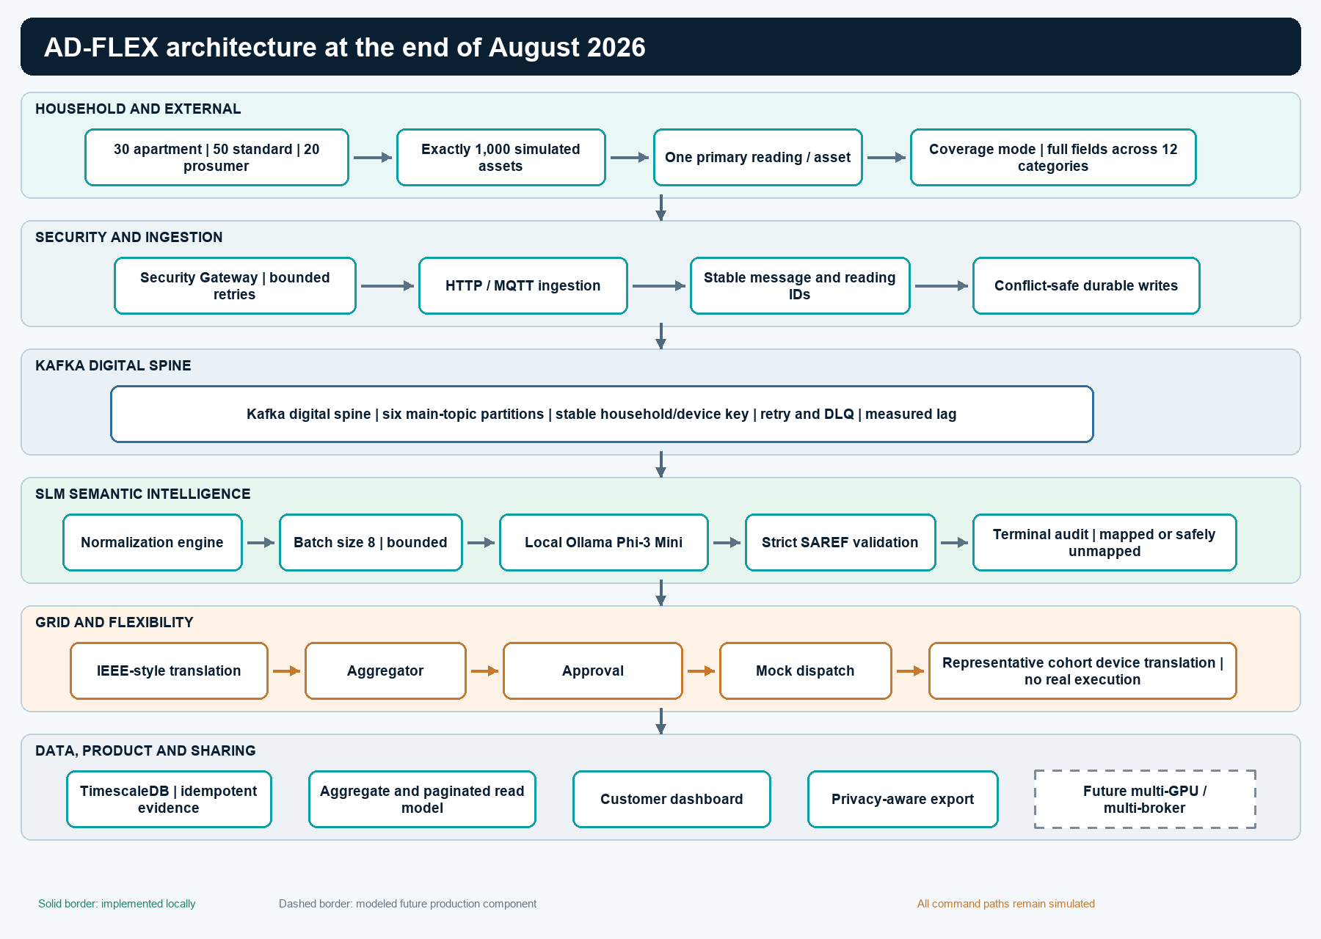
Figure 1. Layered AD-FLEX architecture at 13 August 2026. The future multi-GPU/multi-broker tier is modeled, not deployed.

The business sequence remains unchanged: simulated household assets enter through authenticated HTTP/MQTT paths, Kafka buffers normalized work, local Phi-3 Mini proposes semantics, deterministic SAREF4ENER rules validate the proposal, TimescaleDB records mapped or safely-unmapped evidence, and validated mappings continue into IEEE-style and flexibility services. The exact population layer changes scale and evidence discipline rather than rewriting the pipeline.
The architecture intentionally permits backlog while preventing loss. Six main-topic partitions, stable keys, durable offsets, idempotent writes, and retry/DLQ paths preserve work while the slower local inference tier catches up. Customer pages consume aggregates and paginated records. Future vLLM/GPU replicas and multi-broker Kafka are shown as modeled production work, not current local components.

7. Component Progress
Table 2. Component progress during August 2026
Component | Start-of-month state | Work this month | End-of-month state | Business relevance
Population model | 20 HH / 241 range-random devices | Exact profiles and 1,000-device contract | 100 HH / 1,000 assets reproducible | Comparable portfolio validation
Fleet generator | Bounded scheduler | Primary-reading and exact stage modes | Memory-efficient scale generator | Lower-cost local testing
Semantic connector | Mandatory batching/provider foundation | Category coverage, batch-8 tuning, strict evidence | 100% SLM audit in runs | Governed interoperability
Durability | Conflict-aware writes | Population registry and end-to-end identities | Zero duplicates in authoritative runs | Audit/replay confidence
Kafka | Single-broker local topics | Six partitions, isolated groups, lag evidence | Backlog preserved and cleared | Measurable backpressure
Customer dashboard | Role-scoped bounded product | Scale aggregate, profile/search filters | Responsive 1,000-asset view | Portfolio usability
Scale roadmap | Conceptual | Measured sizing formulas and retention model | Quantified future benchmark plan | Investment planning

8. SLM and Semantic Intelligence
August retained Phi-3 Mini as the mandatory semantic proposal engine. SLM evidence records provider, model, worker, batch, request, attempt, inference timestamps and latency, output receipt, mapping, confidence, deterministic validation, failure reason, terminal status, and safely-unmapped state. Hidden reasoning and unnecessary raw prompts are not stored.
Table 3. Local SLM batch preflight
Batch | Input | Validated | Safely unmapped | Elapsed | Readings/s
1 | 1 | 1 | 0 | 2.07 s | 0.482
8 | 8 | 8 | 0 | 14.63 s | 0.547
16 | 16 | 14 | 2 | 43.07 s | 0.372
32 | 32 | 3 | 29 | 68.18 s | 0.469
64 | 64 | 0 | 64 | 129.11 s | 0.496

Batch 8 was selected because throughput and strict output quality must be considered together. Although batch 64 had a superficially comparable input rate, none of its outputs passed validation. The connector therefore favors useful validated throughput over raw model completion.
Home-battery state of charge remained the most visible category gap in the functional population run: 19 of 20 readings were safely rejected because the local model did not consistently return a permitted property/unit relationship. This is reported as a model/prompt quality issue and is not replaced by deterministic semantics.

9. Household and Device Simulation
Figure 2 shows the exact device-category distribution validated by the August programme.
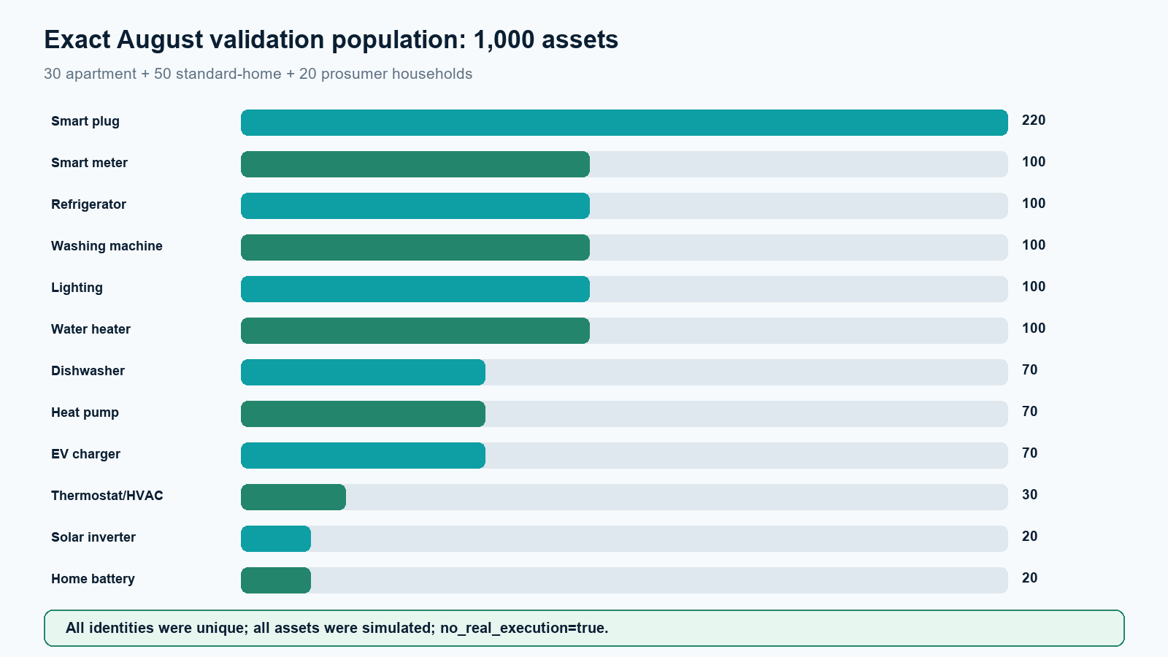
Figure 2. Exact device-category totals across 100 simulated households and 1,000 assets.

Table 4. Exact household profiles
Profile | Households | Assets per household | Assets | Distinctive assets
Apartment | 30 | 8 | 240 | Meter, plugs, refrigeration, laundry, lighting, water heating, HVAC
Standard home | 50 | 10 | 500 | Apartment core plus dishwasher, heat pump, EV charger
Prosumer home | 20 | 13 | 260 | Standard core plus solar, battery, extra smart plug
Total | 100 | - | 1000 | 12 categories

Each household retains profile, time zone, deterministic seed, occupancy and base-load context, and an independent reporting schedule. Each asset retains manufacturer/simulated vendor, measurement capabilities, online and operating state, last seen, current primary measurement, cumulative energy where relevant, flexibility capability, maximum flexible power, simulated=true, and no_real_execution=true.

10. Scalability Development
August moved scalability from architecture preparation into a controlled exact-population programme. Stages were not accepted on gateway response alone. A passing functional stage required every configured identity, every update normalized, every reading assigned a terminal SLM audit, 100% slm_called, mapped-or-safely-unmapped completion, zero duplicate final IDs, no processing errors, measured lag returning to zero, completion of representative safe workflow, and a privacy-aware dataspace export.
Table 5. Authoritative staged functional evidence generated 27 July and integrated in August
Assets | Households | SLM called | Mapped | Safe-unmapped | Completion r/s | Max/final lag | Result
100 | 10 | 100% | 98 | 2 | 0.369 | 93 / 0 | Passed
250 | 25 | 100% | 246 | 4 | 0.386 | 73 / 0 | Passed
500 | 50 | 100% | 487 | 13 | 0.430 | 420 / 0 | Passed
1000 | 100 | 100% | 969 | 31 | 0.424 | 762 / 0 | Passed asynchronously

Figure 3 places the functional and sustained-arrival rates beside their measured Kafka backlog.
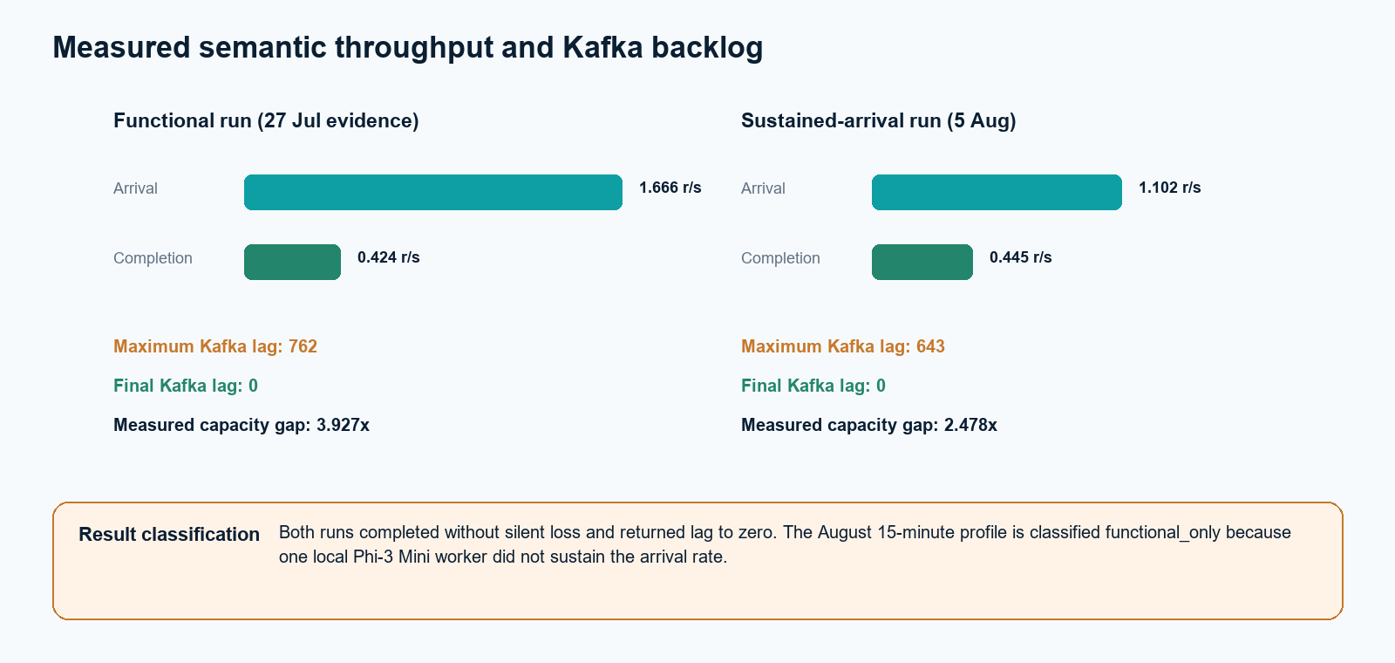
Figure 3. Measured arrival, semantic completion, capacity gap, and Kafka lag for the 1,000-asset evidence runs.

Capacity classification
The platform functionally completed all 1,000 readings and cleared its backlog. It did not sustain the tested 15-minute arrival profile. One local Phi-3 Mini worker requires at least 2.478x measured capacity at that arrival rate, before operational headroom.

11. Validation and Testing
Table 6. 5 August semantic coverage run
Metric | Result
Run ID | scale-100-2026-08-05T06-59-10-798Z
Households / assets / categories | 10 / 100 / 12
Telemetry accepted | 100 / 100
Normalized / terminal SLM outcomes | 374 / 374
SLM invocation | 374 (100%)
Validated / safely unmapped | 339 / 35
Maximum / final lag | 159 / 0
Drops / final duplicates / errors | 0 / 0 / 0
Classification | functional_end_to_end_pass

Table 7. 5 August sustained-arrival 1,000-asset run
Metric | Result
Run ID | scale-1000-2026-08-05T07-15-27-418Z
Households / assets | 100 / 1,000
Telemetry / normalized / terminal | 1,000 / 1,000 / 1,000
SLM invocation | 100%
Validated / safely unmapped | 961 / 39
Arrival / completion | 1.102 / 0.445 readings/s
Maximum / final lag | 643 / 0
Backlog clearance after generation | 1,345.714 s
Drops / duplicates / errors | 0 / 0 / 0
Classification | functional_only

Table 8. August automated validation inventory
Suite or check | Passed
Semantic connector | 44
Security gateway | 42
Engine | 9
Household fleet | 10
Ingestion API | 8
Aggregator | 12
Approval workflow | 20
IEEE translator | 9
Mock dispatch | 11
Device command translator | 12
Dataspace export | 14
Shelly/Enode/heat-pump simulators | 15
Scale generator/evidence | 11
Customer product boundaries | 8
Total automated tests | 225
JavaScript syntax files | 132
PowerShell syntax scripts | 21

12. Customer/Product Development
The August dashboard work did not recreate the July customer product. It extended the existing read model for the exact scale cohort. Community summaries return exact household/profile/category totals and semantic readiness. Device lists accept household, category, profile, search, online, flexibility, and state filters with server-side pagination. Technical Kafka, model, and database diagnostics remain restricted to the internal operations dashboard.
Figure 4 shows the 5 August community-scale evidence. The profile and category values match the registered simulator population.
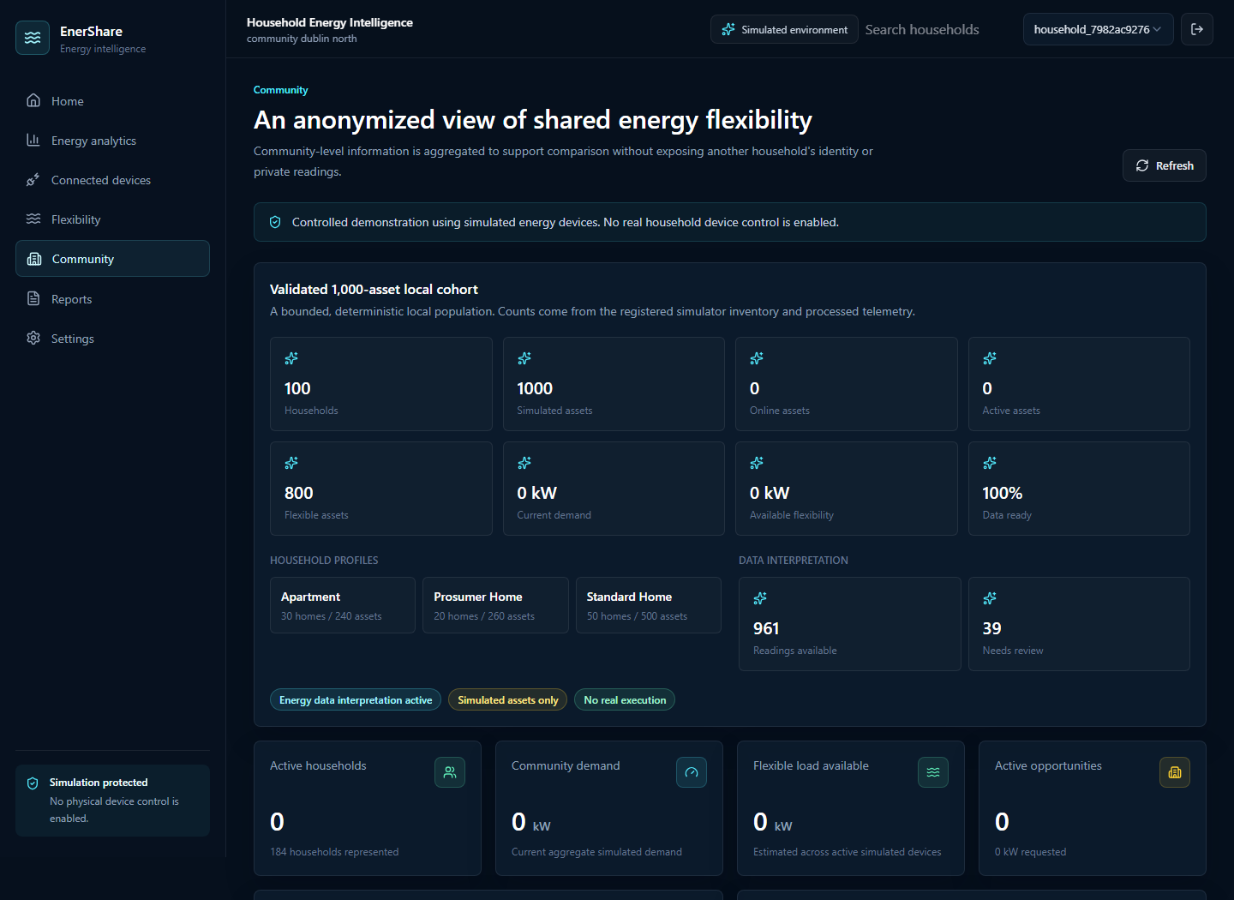
Figure 4. August customer community view showing the exact 100-household/1,000-asset cohort and privacy controls.

Ten community aggregate queries averaged 1.25 seconds with p95 1.33 seconds. Ten filtered 25-row device queries averaged 0.96 seconds with p95 1.04 seconds while local inference was active. Browser pages remained bounded and responsive at desktop, tablet, and 390-pixel mobile widths. The dashboard reports simulation status and does not imply that current assets are physical customer devices.

13. Business Value for EnerShare
Reproducible portfolio evidence: exact profile and category totals support repeatable demonstrations and technical reviews.
Auditable semantic intelligence: every reading has an SLM call and terminal validator outcome, including safe failure rather than silent substitution.
Operational resilience: Kafka preserves backpressure until the slower inference layer finishes, with zero silent drops in authoritative runs.
Customer-scale usability: aggregate and paginated reads show portfolio status without exposing all assets or technical diagnostics to the browser.
Safe flexibility demonstration: representative profile cohorts moved through proposal, approval, mock dispatch, and simulated provider translation.
Measured investment case: the 2.478x local inference gap and storage/query measurements provide concrete inputs for the next GPU/vLLM benchmark.
Transparent governance: the report distinguishes functional completion, sustained capacity, simulation, certification status, and future infrastructure.

14. Technical Challenges and Resolutions
Table 9. Technical challenges and resolutions during August
Technical challenge | Impact | Resolution | Result
Seven transport failures in initial 250-asset attempt | Stage incomplete | Bounded retry with stable identities | Authoritative rerun accepted all 250
Nullable metadata disagreed with handwritten validation | Valid coverage envelopes rejected | Aligned validator and added test | Coverage run proceeded
Demo fleet interfered with one run | Evidence isolation risk | Excluded run; added group/fleet isolation checks | Fresh evidence isolated
Large batches lost structured-output quality | Most mappings rejected at 32/64 | Benchmarked and selected batch 8 | All eight preflight outputs valid
Inference below arrival rate | Kafka backlog grew | Preserved backpressure; measured clearance and capacity gap | No loss; sustained criterion correctly failed

15. Safety, Security and Governance
All external test traffic continued to pass through the security gateway, and customer reads continued through server-side BFF routes. Stable correlation and reading IDs supported audit and duplicate checks. Household authorization, pseudonymized operator selection, small-group privacy, query bounds, and sanitized error handling remained in place.
Semantic safety required slm_called=true for every normalized reading. Strict output validation rejected unsupported concepts, properties, units, confidence levels, duplicate/unexpected IDs, missing mappings, and command-like content. Exhausted readings became explicit safely-unmapped records. This preserved data integrity while preventing deterministic logic from disguising model failure.
Control and certification boundary
The approval, mock dispatch, and device translation stages remained simulated. Unsafe execution rows were zero. No physical device control, provider credentials, certified IEEE 2030.5 implementation, certified ENERSHARE/IDS connector, or production customer identity was added.

16. End-of-Month Project Status
Table 10. August maturity classification
Classification | Items
Implemented | Exact population configs; primary-reading mode; idempotency migrations; category guardrails; stage/evidence scripts; scale-aware customer filters
Validated | 100/250/500/1,000 functional stages; 5 Aug coverage; 5 Aug functional completion; 225 tests; customer scale queries; safe workflow
Implemented but under validation | Sustained inference capacity, home-battery semantic quality, enforced household cohort targeting
Future / production infrastructure | GPU vLLM replicas, multi-broker Kafka, HA storage, regional ingestion, production IAM/mTLS, real integrations and certified connectors

17. Next Development Priorities
Benchmark candidate local or dedicated GPU inference servers through the existing vLLM-compatible adapter using the same strict validator.
Raise validated semantic completion above the required arrival rate with operating headroom before repeating the sustained test.
Investigate home-battery state-of-charge prompt/model behavior and retain safe-unmapped outcomes until quality passes.
Run a controlled 10,000-asset validation only after the 1,000-asset sustained gate passes; do not extrapolate queue acceptance.
Test multiple semantic workers and inference replicas with rebalance, failure, replay, and idempotency scenarios.
Replace local aggregate scans with incremental/materialized customer aggregates as population and history grow.
Define an authorized household/cohort target contract before any future real-device or real-DSO sandbox work.
Advance production identity, secrets, mTLS, retention, backup, monitoring, governance, and consent as separate deployment workstreams.

18. Monthly Achievement Summary
Table 11. August management achievement summary
Area | Start of month | Improvement during month | End of month | EnerShare value
Population | 20 HH / 241 devices | Exact profiles and stage subsets | 100 HH / 1,000 assets | Reproducible portfolio evidence
Semantics | Batch/provider foundation | Category coverage and batch-8 selection | 100% SLM terminal evidence | Trusted vendor-neutral interpretation
Durability | Conflict-aware writes | Stable IDs and uniqueness migrations | 0 duplicates in final runs | Replay and audit confidence
Scale result | Initial scale constraints | Staged plus sustained classification | Functional pass; sustained gap measured | Clear capacity decision
Customer product | Bounded role-aware UI | Exact cohort aggregate and filters | Responsive 1,000-asset view | Portfolio usability
Future planning | Conceptual roadmap | Measured sizing model | Transparent 10k-1m assumptions | Investment and benchmark planning

19. Conclusion
August moved AD-FLEX from a broad multi-device demonstration to a controlled exact-population validation. The repository now represents 100 households and 1,000 simulated assets reproducibly, submits every normalized reading to local Phi-3 Mini, validates semantics deterministically without replacement mapping, preserves durable identity through retries, and exposes the cohort through aggregate and paginated customer views.
The local result is a credible functional end-to-end pass. It proves eventual processing, audit, storage, IEEE-style continuation, representative flexibility workflow, mock device translation, privacy-aware export, and dashboard visibility without drops or duplicate final records. It does not prove sustained real-time capacity. The 5 August test measured 0.445 readings/s completion against 1.102 readings/s arrival, making the single local inference tier the exact constraint. The project is therefore ready for a measured multi-replica GPU/vLLM benchmark and larger controlled validation, not for a million-device or production-readiness claim.

Appendix A - Git Evidence
Table 12. Significant August commit reviewed
Date | Commit | Description | Principal components
5 Aug | f0bd3a1 | Exact 100-household/1,000-asset implementation, evidence, and reporting | 224 files: configs, migrations, fleet, engine, semantics, gateway, dashboard, scripts, results, docs

The commit contains generated runs dated 27 July as well as fresh 5 August runs. Execution date and first Git inclusion are distinguished in the evidence audit and throughout this report. No later August commits were present as of 13 August.

Appendix B - Validation Evidence
docs/1000-assets-validation-report.md
docs/1000-assets-client-summary.md
docs/1000-assets-workload-definition.md
docs/100-household-device-model.md
docs/1000-assets-limitations.md
docs/million-device-scale-out-model.md
docs/scalability-results/scale-100-2026-08-05T06-59-10-798Z/stage-result.json
docs/scalability-results/scale-1000-2026-08-05T07-15-27-418Z/stage-result.json
the associated JSONL, CSV, category outcomes, lag, throughput, resource, query-benchmark, chart, and screenshot files
docs/monthly-reports/August_2026_Evidence_Audit.md

Appendix C - Current Limitations
One local Phi-3 Mini worker did not sustain the tested 15-minute 1,000-asset arrival profile.
Home-battery state-of-charge interpretation had a high safe-rejection rate and requires model/prompt evaluation.
The local deployment has one Kafka broker and one TimescaleDB instance; failover, HA, regional recovery, and production service levels are untested.
The selected 15-household flexibility cohort is audit context; the current DSO request remains community scoped.
10,000-, 100,000-, and million-asset figures are modeled future infrastructure requirements, not completed validations.
All devices and commands remain simulated with no_real_execution=true; no real credentials or customer consent integration exists.
Production identity, mTLS, secrets, monitoring, retention, backup, cost governance, and connector certification remain future work.
No financial savings, tariff optimization, carbon benefit, or billing-grade accuracy is claimed.

